DERO Technical Services
Bob Cornacchioli
315 Mill Street
Worcester, MA 01602
bcornacchioli@gmail.com
get2bobc@gmail.com

Implementing Standards- Steps to Success for your school* and District
DERO now offers assistance (onsite if required) with any or all of the following implementation steps. Quotes depend upon your current PowerSchool set-up and the your scope of work. We have assisted many districts around the world using our “we train you model” to become independent in this process including making their own standard based report cards.
*Please Note: Often one of several elementary schools in a district might like to pilot standards in advance of others. It has been our experience that leadership is mission critical. If the other schools/staff understands that “school A” is piloting DISTRICT standards they will be more receptive that the grade level standards and scales represent their curriculum too. For example, if a district has multiple grade 4 classrooms in several buildings and the curriculum is the same, the standards should be too. Avoid the trap that may have other teacher’s say- “who came up with these?” Encourage a representative from each school to participate with the curriculum team that is developing these standards and be proactive in your communications with the other schools. It can work!!!
Sharing "Best Practices" for implementing standards in your school
The standards movement builds on the concept of personalized learning for success where students...
- are all active and engaged
- take an active role in setting their learning goals
- work collaboratively to solve problems
- are self-motivated and take responsibility for their learning.
- become researchers, authors, mathematicians, scientists and historians teaching others what they discover.
- Bring curriculum and technology specialist together to discuss desires and constraints with PowerSchool.
- The collaborative "line in the sand" between the two sides is mission critical. As issues arise, determine if it's a curriculum or technical issue. Let the right staff make the work around decision.
- Determine if your state has adopted the Common Core Standards (CCS)
- Determine if your district will be adopting or adapting these CCS. Most districts are creating collaborative grade level teacher teams to "cherry pick" selected CCS that match their own local/state curriculum.
- If your district is creating standards consider grade level teams of teachers. Additionally be ready to "referee" some of these discussions*

* A client in a tropical location when asked about the delay in providing standards in a timely manner said "heavy wet snow would be easier to move than my third grade teachers!" A week later, after a significant investment of his time, his email subject title was "Driveway Cleared!". His 2 – third grade teachers finally agreed on the language and number of standards.

- Set parameters on the number of standard per content areas based upon your local values. This is very helpful especially for those constructing the report card. Wouldn't be nice if you didn't have to create a template for each grade level. If the # of standards per core subject area differs by grade level, sometimes it doesn't by grade level cluster K-2 is the same and 3-5 is the same ( two templates needed – each report card can have their own standards!
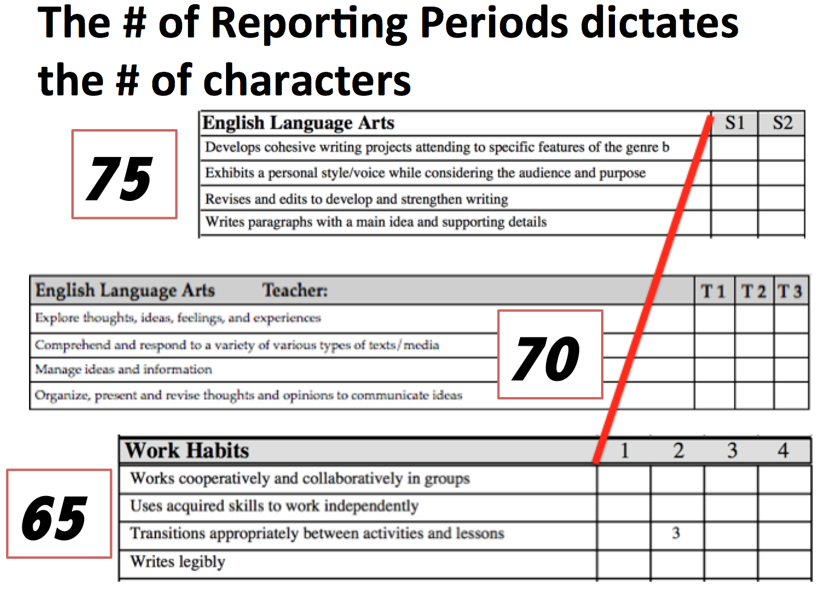
- The name of the standards should not exceed 65 characters** in length including spaces. This is due in part to the constraints of PowerSchool and the creation of the report card. Most SBRC are created using landscape 8.5 * 11 paper with two columns. If you are using three columns, you may even have to reduced this # further.
- Your goal should always to complete the creation of your report cards BEFORE the end of school to post grade level report cards can be shared with stakeholders!
- Check with your technology team to determine if they have the skills and/or time to take on the tech side of this initiative. Consultants are available – They/ME too need adequate time to assist as well.
Six or more Months Before Implementation (Curriculum) A suggested tasks/benchmark can be found on my website (http://www.derotechnical.com/STANDARDS/Standards.html) in the second row of the table.
- These changes require ample time "in advance of your start date" for immediate and ongoing professional development for teachers where they…
  - work collaboratively around best practices and creating standards – LESS IS MORE.. too many creates confusion in the eyes of the teacher, student and parent. Too many standards may result in scores without evidence and potentially less thoughtful narrative comments.
  - create new forms of assessments
  - use student performance data to inform and personalize instruction. This takes lots of time
  - work with students individually and in small groups helping students meet their individualized learning goals
  - receive targeted training specifically to their learning needs
  - learn the technical aspects of grading after they have a base foundation of aligning their teaching and assessment with the new report cards.
  - focus on quality comment writing strategies
  - look at student work so everyone knows what 4,3,2,1 work looks like.
- Communication in advance to the parent community can't be overlooked. Patience and understanding from parents and students go a long way when schools are working out bugs in a new program.
- While you are developing your standards, begin discussions of your teachers grading practices. All to often this aspect of your standards movement is given insufficient professional development.
  - Create an Implementation Timeline with Benchmark Dates
  - Google Standard-based education – learn the authors
  - Search You Tube for various Standard-base guru's
  - Consider including a standards video/reading/discussion to all faculty/grade level meetings
  - If you are implementing Common Core standards, have your teachers "cherry pick" from that list standards that best match your existing curriculum and state requirements. NO ONE USES ALL THE COMMON CORE STANDARDS!
- Set deadlines of 1st Draft of the standards by the grade level teams.
- Use the UNFRIEND social media technique (on Implementing Standards PPT) to reaffirm Final Draft – do the standards selected lend themselves to be associated to assignments.
- Determine what the performance indicators for academic and social emotional standards.
- Discuss how these performance indicators (4,3,2,1 or O,S,U,N etc) apply to special needs and or gifted students.
- Communicate with staff and do not forget PARENTS... let them know this is coming!!!
The change from ABC grades in a single content area to some performance indicator scale (4,3,2,1 ) in a variety of standards under these traditional content areas allows parents…
- to take an active role in their child's education
- to focus on a particular skill
- to be more aware of what is being taught
- to learn process all the new information provided at grading time otherwise they will only focus on the teacher comment area
- to ask schools to provide resources and tools to help their children at home in a particular standard BE PREPARED!

- Set district expectations for comments: personal comment bank or narrative
- Discussing assignments vs. standard assessments and gradebook totals- average/recent 3 etc
No later than the Spring Before Implementation (Technical)
- All standards need to be associated with courses in PowerSchool
- Check your Schedule in PowerSchool, do all teachers have students enrolled in their classes?
  - If YES – does this include all specialists?
  - If NO – you may need to properly schedule your building to provide teachers with standards in the classes they teach.
- 21st Century Effort standards (Habits of Mind, Successful Skills for Learning- go to HR??)
- All teachers need to be associated to sections in PS to assess students
- Review current schedule (specialists/days/periods) – are all teachers’ assigned classes in PS**?
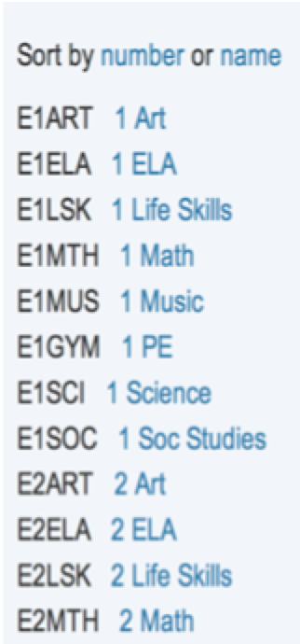
- If you want specialists to assess students in their particular content area
- Students have to be scheduled in PowerSchool into each of these subjects

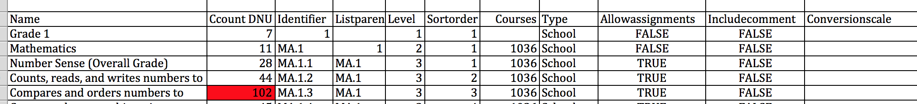
- Using Excel prepare a standards import template. PS 8 and PS 9 templates can be found on my website

- Create or contract to create your standard-based report card
- Share draft with staff before summer break – this can be a word document!
- Consider posting on your website for parents
- Determine the character count of narrative comments and MORE IMPORTANTLY:
  - Who has to write a comment
  - Display current comment or ALL comments on the report card < PREFERRED!
  - District or Personal Comment Bank or Narrative?

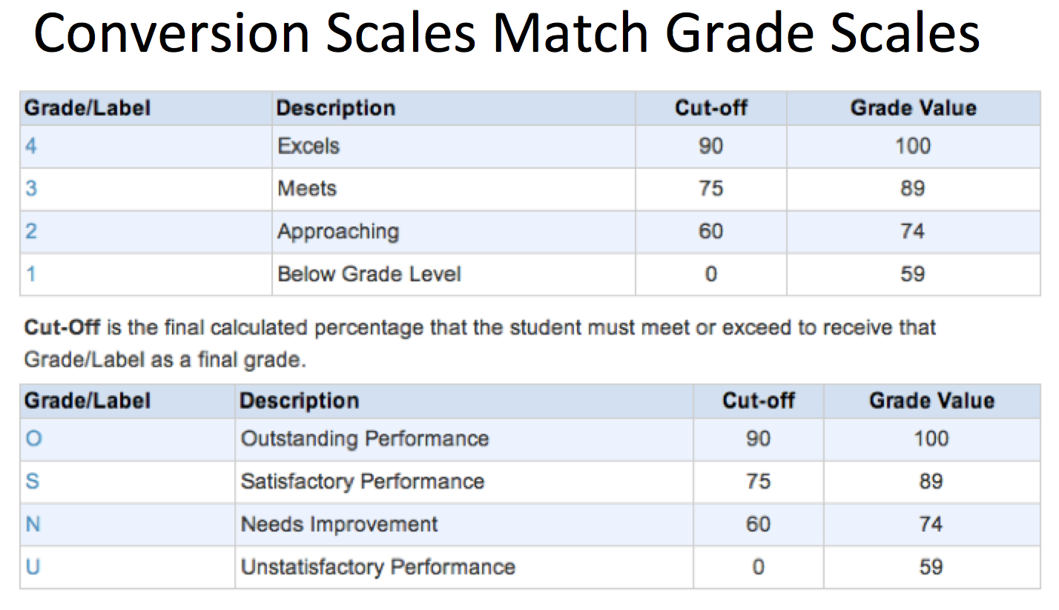
- Create grade/conversion scales for the performance indicators above include cut-off values

Once School Starts (Using Gradebook and Print Options)
- Just in Time Training- how to teachers enter grades – how to print report cards
- Consider having a group of vanguard teachers create professional development documentations or screen capture how to videos – Jing/Quicktime Recorder

